Contents
Background 1
Configuration 1
Menu Options 1
Activate Pay Scale Bands 2
Define the Bands for a Pay Scale 2
Adding a new Pay Scale Band 2
Amending an existing Pay Scale Band 3
Deleting a Pay Scale Band 4
Configure the eRecruitment Site 4
Configure Search Appointments Version4 4
Configure Pay Scale item 5
Configure Grade and Salary item 5
Configure Form Profiles 6
Configure Pay Scale item 6
Configure Grade and Salary item 7

Background
Each vacancy can include a Grade and Salary field. This is generally used to share salary/pay related information when the vacancy is advertised.
The Pay Scale Band functionality allows for the Grade and Salary to be automatically updated to reflect a salary range, based on the Pay Scale selected, i.e. once the Pay Scale is set on the vacancy e.g. “Grade 1” then the Grade and Salary is automatically updated to the corresponding salary range for that grade e.g. “£25,000 - £35,000”.

Configuration

Menu Options
The following menu options are required for a user to access the Pay Scale Bands options on the Recruitment Toolbox:
Coreportal Recruitment - Pay Scale Bands Edit
Coreportal Recruitment - Pay Scale Bands View
Both menu options must be added to the relevant menu profile to allow system administrators to view and edit the Pay Scale Bands screen.

Activate Pay Scale Bands
The Pay Scale Bands feature must be switched on in order for the Grade and Salary to be auto-populated based on the configured ranges. Navigate via:
Administrator Dashboard > Admin Settings

Search for parameter “cp_erc_auto_bands”.
Click on Edit and set Current Value to Y to activate.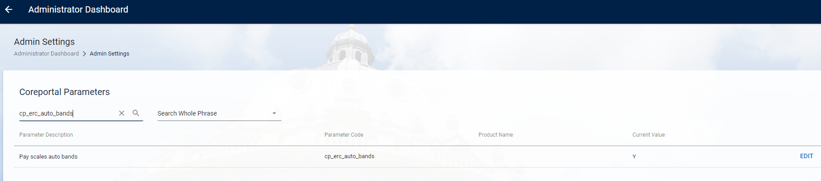

Define the Bands for a Pay Scale
Navigate via:
Recruitment > Toolbox > Pay Scale Bands

Once on the Pay Scale Bands screen all active pay scale bands will be displayed.
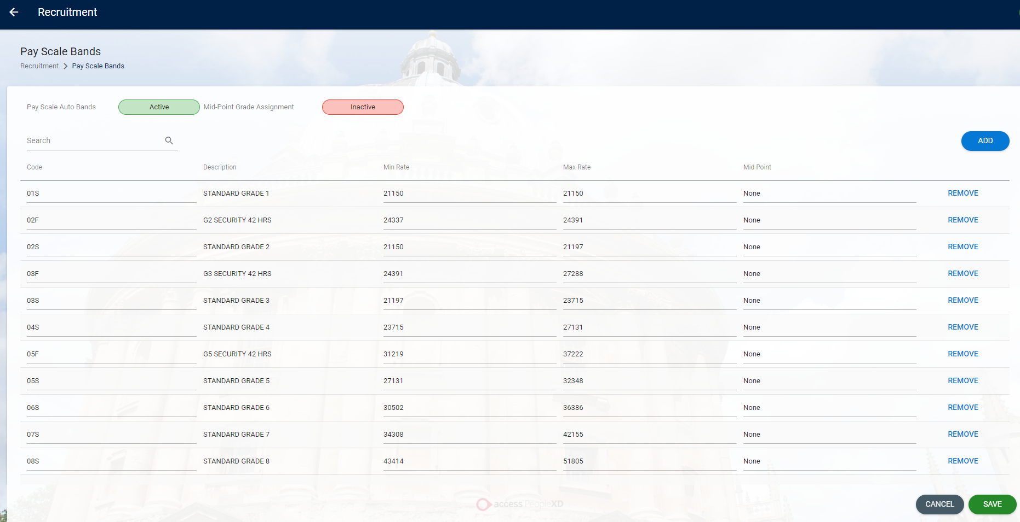

Adding a new Pay Scale Band
On the Pay Scale Bands screen, click the “Add” button at the top right. A new field will open:

Select the Pay Scale code from the drop down list, or type in (e.g. “03F”):

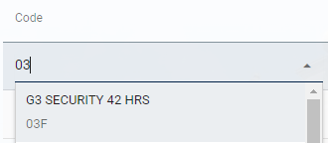

When a code is selected, the description will default into the Description field:
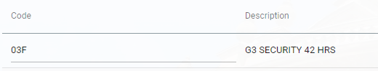
In the Min Rate and Max Rate fields, enter the minimum salary and the maximum non-discretionary salary for the pay scale:
Set Mid-Point to None.
Click SAVE at the bottom of the screen to save the new Pay Scale Band.


Amending an existing Pay Scale Band
Navigate via:
Recruitment > Toolbox > Pay Scale Bands

Select the pay scale band you wish to edit. Click into the Min Rate and Max Rate fields to amend them as required; then click “Save” at the bottom of the screen to save your changes.
If updating the Pay Scale Bands after a Pay Uplift, it is recommended to run report PAYSUP02 Non-Discretionary Salary Ranges after the rates have been updated so that rates above the incremental bar are not included in the Pay Scale Band rage.

Deleting a Pay Scale Band
Select the pay scale band you wish to delete. Click “Remove” to delete it from the screen; then click “Save” at the bottom of the screen to save your changes.



Configure the eRecruitment Site
Navigate via:
Recruitment > Toolbox > Recruitment Admin

Configure Search Appointments Version4
Open Recruitment Admin and select the Company as University of Oxford and Form Type as E-Recruitment Form.
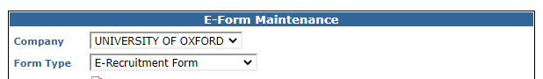
From the list of options, select Appointments Version 4. This is where you configure the options for the Job Search results page on the eRecruitment website.

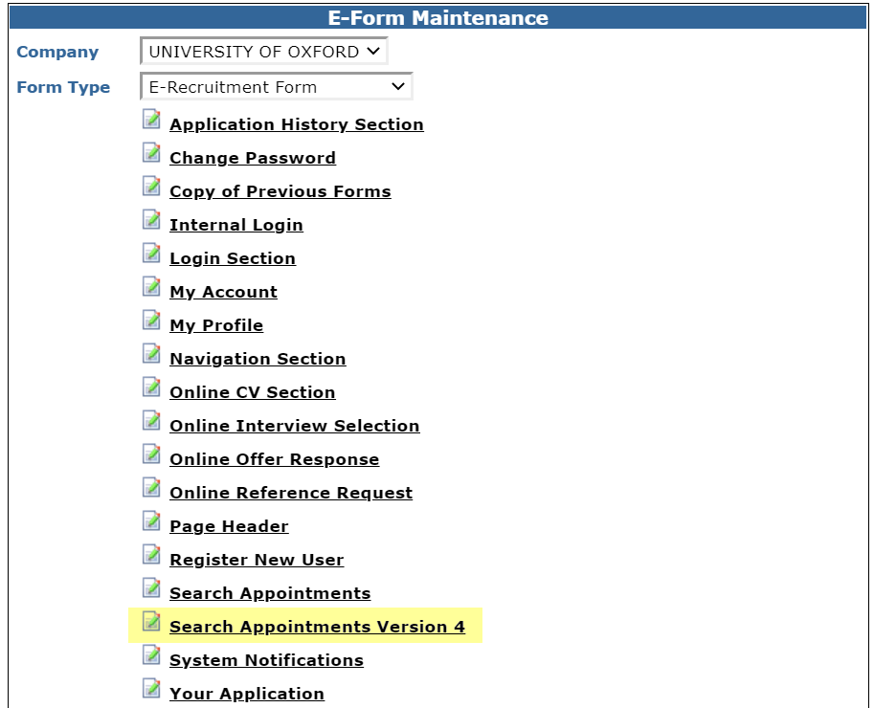

Scroll to the Search Appointments Version 4 Results Section and tick “Include” for the Pay Scale and Grade and Salary items.

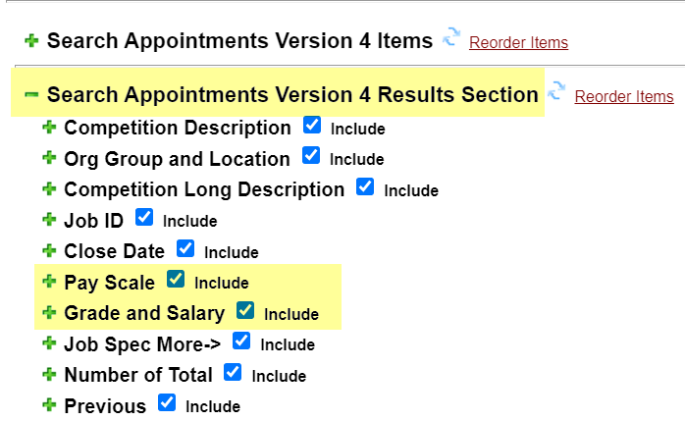

Configure Pay Scale item
Expand the Pay Scale item by clicking the plus sign (+). Apply the following configuration settings:

Field | Setting
Display Order | 6
Sort Order | 7
Sort Direction | Ascending
Label | Pay Scale
Heading Style | Heading Style 5

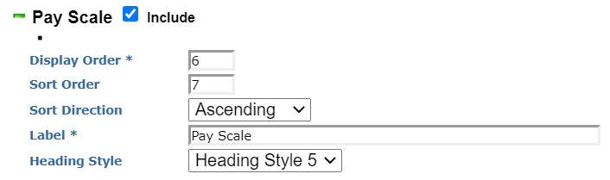

Configure Grade and Salary item
Expand the Grade and Salary item by clicking the plus sign (+). Apply the following configuration settings:

Field | Setting
Display Order | 7
Sort Order | 8
Sort Direction | Ascending
Label | Salary (£)
Heading Style | Heading Style 5

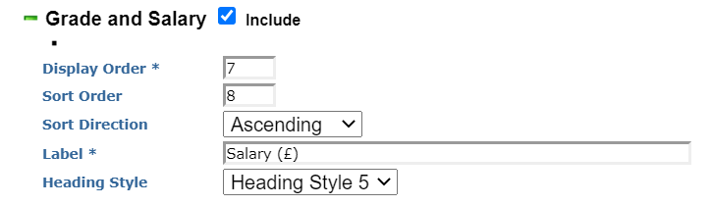

Click the Save button at the bottom of the screen to save your changes to the Search Appointments Version 4 form.

Configure Form Profiles
At the bottom of the screen, select a Form Profile and click Edit to open it.

The Form Profile page will open. On the screen, select and expand Job Specification Section v4. This is where you configure the options for the vacancy specification pages (which are access via the Search Results page). Once again, the items to configure are Pay Scale and Grade and Salary:

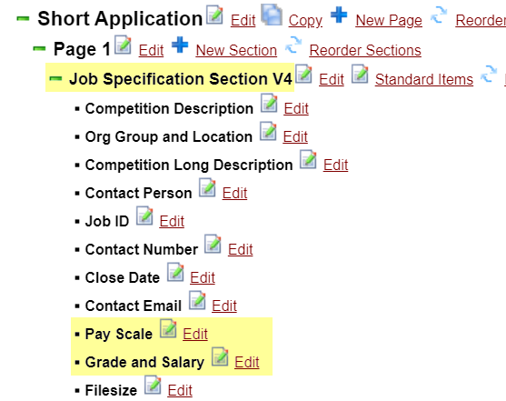

Configure Pay Scale item
Click the “Edit” link next to the Pay Scale item. The Items Job Details screen will open. Scroll to the Pay Scale item and apply the following configuration settings:

Field | Setting
Include | (tick this box)
Order | 9
Required | (tick this box)
Label | Pay Scale
Short Hint | blank
Help Text | blank
Heading Style | Heading Style 5

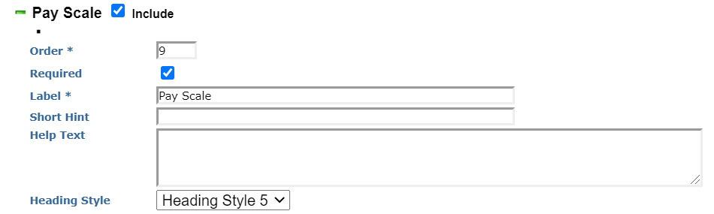

Configure Grade and Salary item
While still on the Items Job Details screen, scroll to the Grade and Salary item and apply the following configuration settings:

Field | Setting
Include | (tick this box)
Order | 10
Required | (tick this box)
Label | Salary (£)
Short Hint | blank
Help Text | blank
Heading Style | Heading Style 5

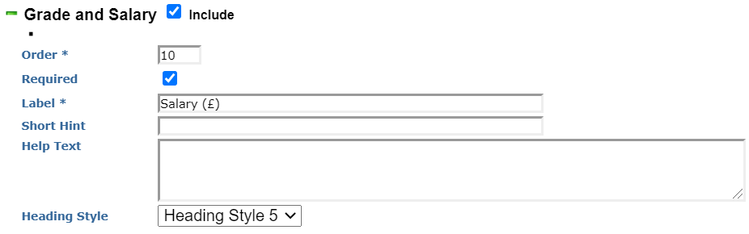

Click the Save button at the bottom of the screen to save your changes to the form profile. You will need to repeat these steps for each active form profile used by eRecruitment.

